Database Course Project

Steven Bishop

Liberty University

CSIS 327 B01 Spring

Professor Matthew Adkins

March 8, 2019

The European Christian Heath Care Group was established back in April of 1999 in Copenhagen Denmark by a small group of Christian health care professional who had a desire to offer affordable heath care to missionaries serving in western and northern Europe. To accomplish this task, they formed a network of doctors from most disciplines who worked out of local health care facilities. Missionaries can see these doctors for a substantially reduced price while serving in the mission field. Today the network spans cities in 15 different countries.

The Network is funded mostly by donors and Volunteers as a means of keeping the cost low for missionaries. They have begun to open their own dedicated facilities offering services such as primary care, neurology, general surgery and much more. The network also provides medical students specialized job training medical students in 11 different areas of study. The network also has specialists who provide services in disaster relief and infectious diseases and offers aid during a crisis.

The network has turned its focus to establishing missionary training and has begun construction of a dedicated learning center to offer world class ministry training for discipleship, missionary training and church building. Currently there is only a small number of missionary outposts, but the team is working hard to expand. A new database has been constructed so that the network can be mapped, to determine where the network needs to expand next.

# ER DIAGRAM

# TABLE CREATION

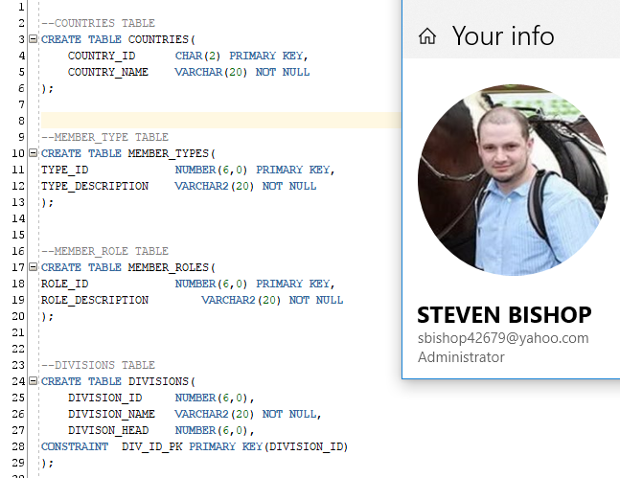

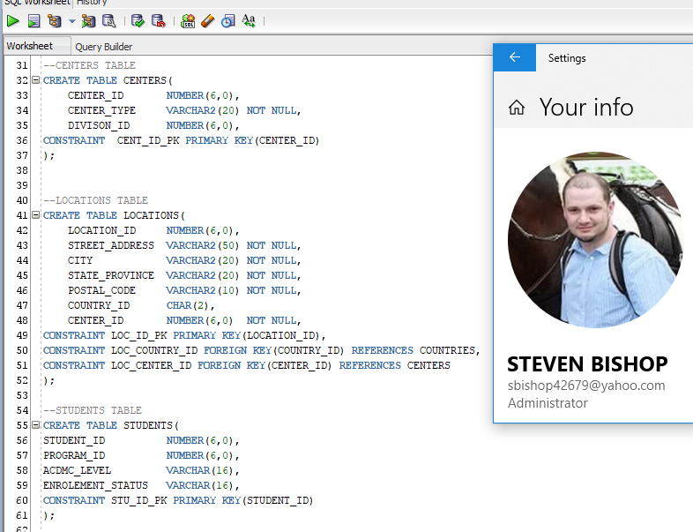

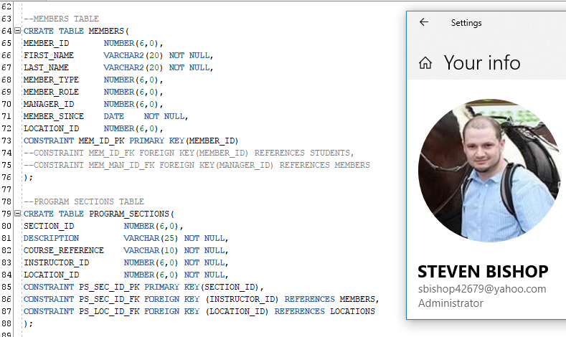

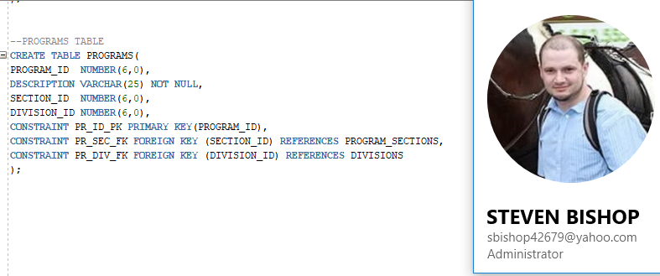

# TABLE ATERATIONS

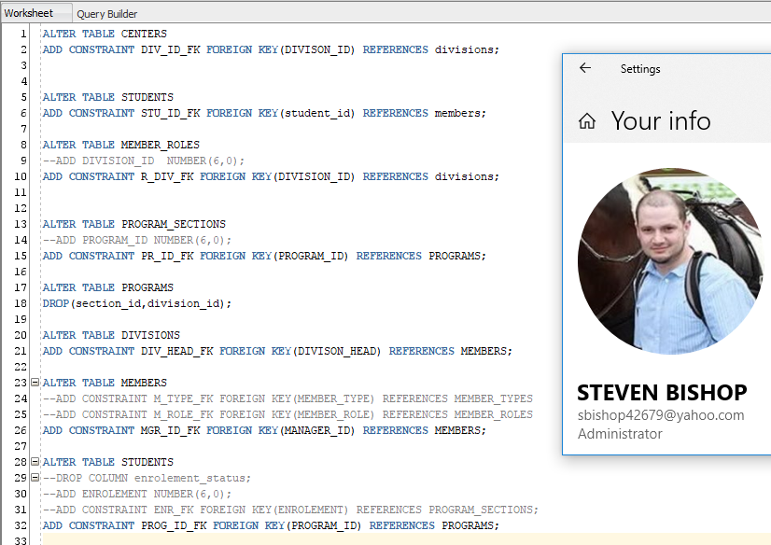

# TABLE DETAILS

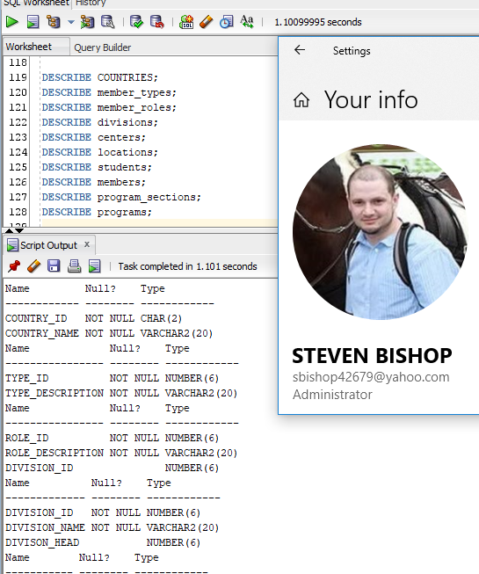

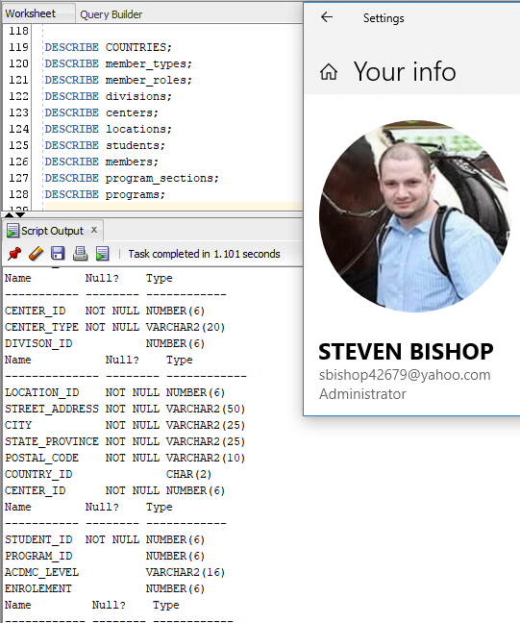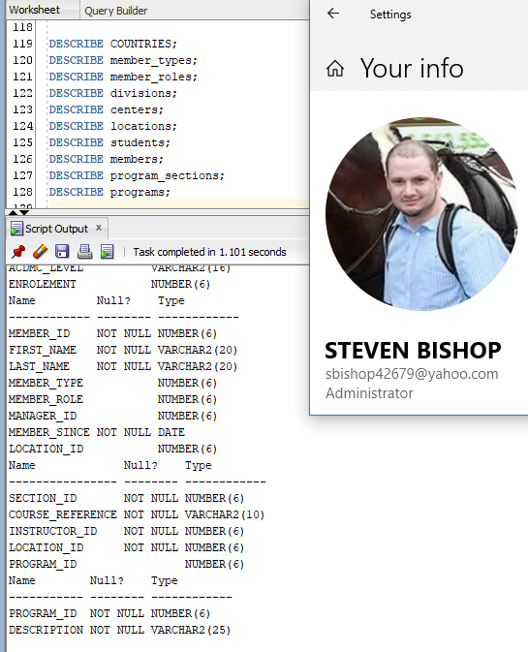

# DATA ENTRY

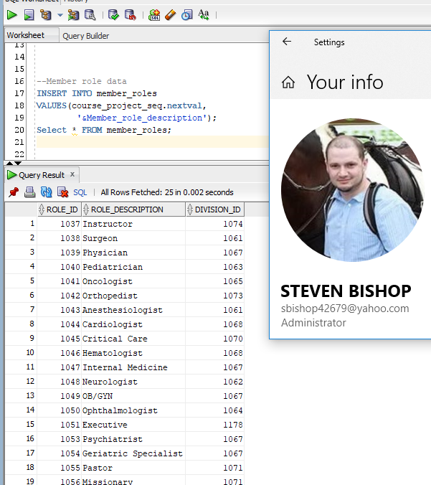

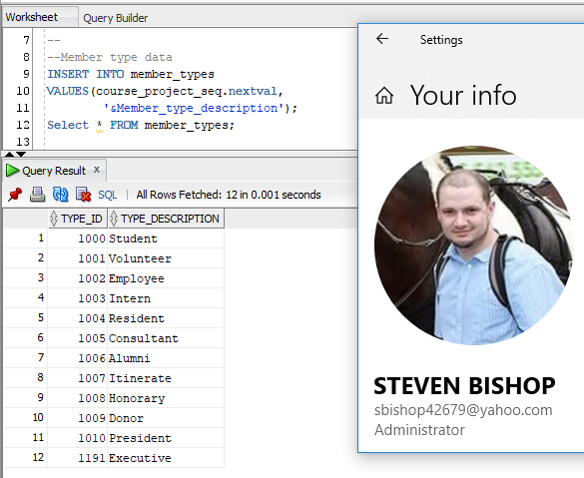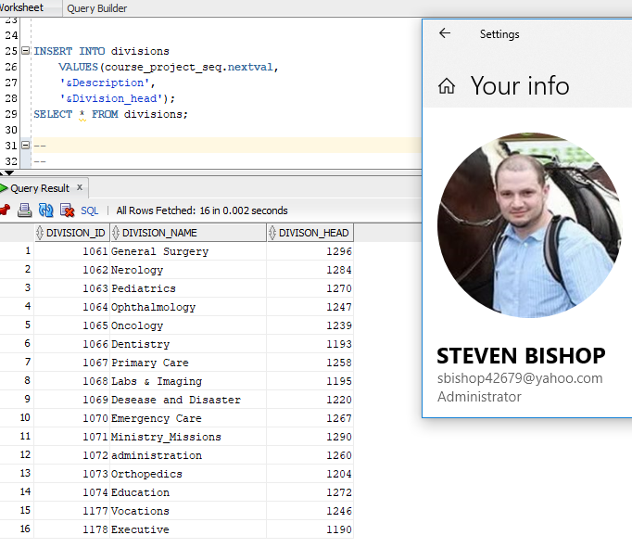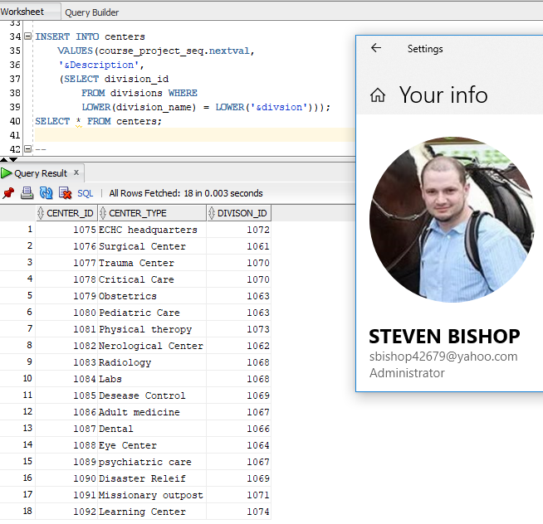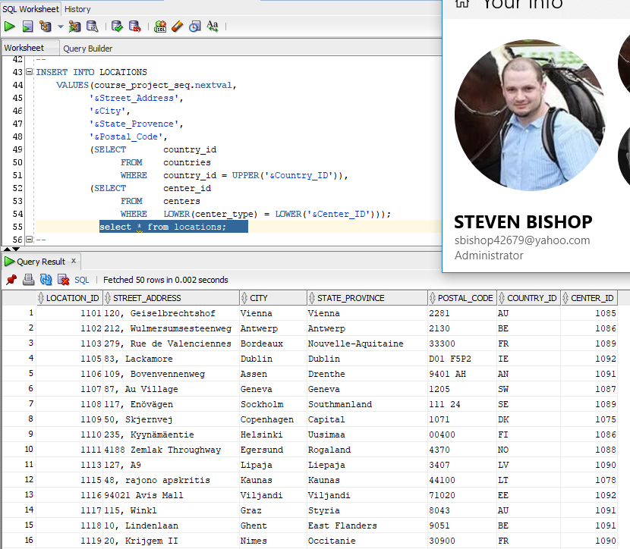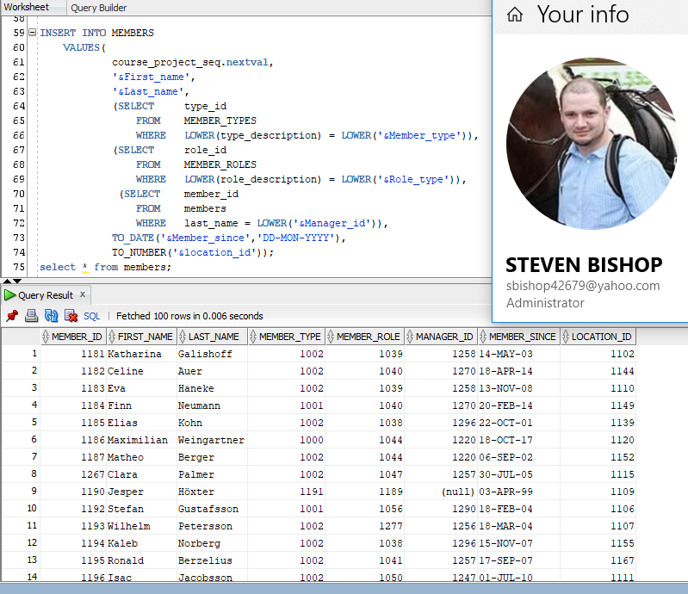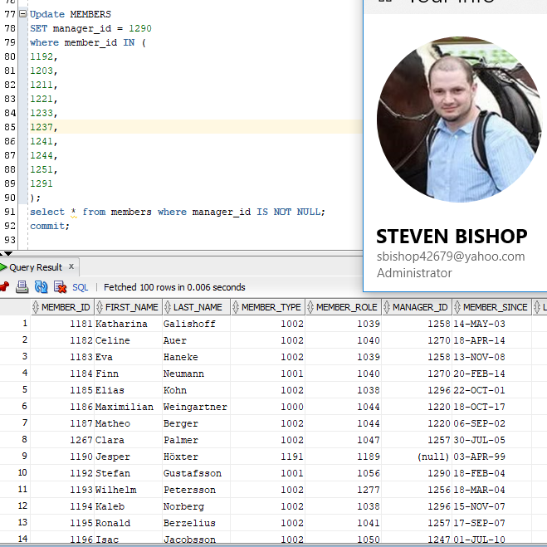I had to add manager id data afterward with an update

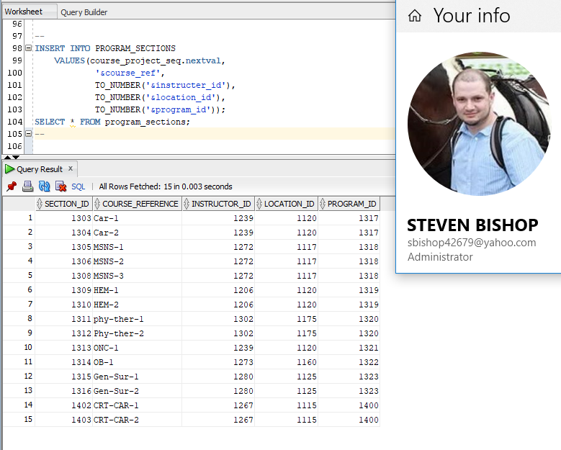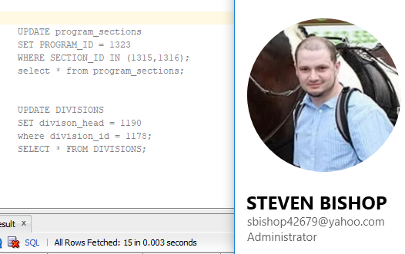

A few more updates I needed to make

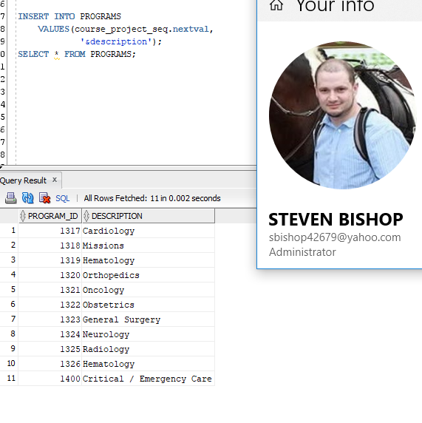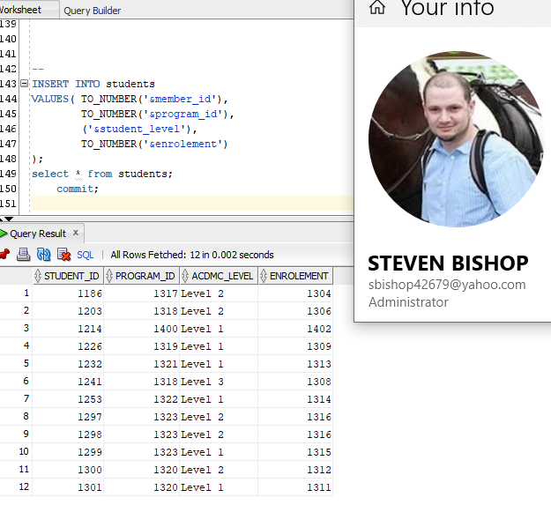

## SEQUENCE & INDEX

Machine generated alternative text:
sequence _and _index sq' 
W orksheet 
Quer y Builder 
- -project sequence 
•CREATE SEQUENCE course_project seq 
START WITH 
1000 
INCREMENT BY 1 
:MINVALUE 1000 
:CACHE 100 
• NOCYCLE,• 
—project indexes 
Script Output x 
Task completed in O. seconds 
sequence COURSE PROJECT SEQ created. 
Settings 
Your info 
STEVEN BISHOP 
sbishop42679@yahoo.com 
Administrator 

Machine generated alternative text:
- -project indexes 
: CREATE INDEX mem name tax 
: ON members (first_name, Last_name) ; 
CREATE INDEX m role desc 
member roles (role description) ; 
:cREATE INDEX address 
Locations (street address, city, postal code) ; 
Script Output x 
Task completed in O .05 seconds 
Index MEM IDX created. 
Index ROLE DESC 
IDX created. 
Index ADDRESS 
IDX created. 
Your info 
STEVEN BISHOP 
sbishop42679@yahoo.com 
Administrator 

## VIEWS

Machine generated alternative text:
-View for the Head of Missions 
3 (S:CREATE VIEW Missionary 
first name Il ' ' 
Last name "MISSIONARY um-E", 
mt. type_description "MISSIONAY TYPE" , 
L.city "CITY OF SERVICE", 
c. country_name "NATION" , 
members m 
member _ types mt 
mt. type _ id = m. member_type 
"YEARS OF SERVICE" 
: JOIN 
Locations L 
L. Location id — 
countries c 
m. Location id 
c. country _ id = L. country _ id 
mt. type_description NOT IN ( ' Alumni ' ) 
m. manager_id = 1290; 
from missionary 
Script Output x >QueryResuIt x 
SQL All RowsFetched: 10 in 0.005seconds 
Settings 
Your info 
STEVEN BISHOP 
sbishop42679@yahoo.com 
Administrator 
MISSIONARY NAME 
I Josephine Tison 
2 Lillem•r BerzeLius 
3 Alexander Berkeley 
4 Lilah Wise 
5 Marceau Chapel Le 
6 Maéva Mangin 
MISSIONAYTYPE cm OF SERVICE 
NATION 
must r la 
Austria 
Be Lg fum 
Be Lg fum 
I re Land 
Ire Land 
Nether Land s 
Nethe r Land s 
Norway 
Estonia 
YEARS OF SERVICE 
7 Finlay 
8 
Stef an 
g Ismael 
10 
Birgit 
Robert s 
Gustafsson 
Student 
Student 
Emp Loyee 
Vo Lunteer 
Vo Lunteer 
Emp Loyee 
Emp Loyee 
Vo Lunteer 
Parv Ian Inen Volunteer 
Heinrich Volunteer 
Graz 
Graz 
Charleroi 
Ghent 
Drogheda 
Dub L in 
Bols ard 
As sen 
Ha Iden 
TaLLinn 

Machine generated alternative text:
-View for head of education Hanson 
E: CREATE VIEW Student enrolement 
m. first name 
Il m. Last name 
"STUDENT Hue" , 
ps . course _ reference "ENROLED IN" , 
p. description "MAJOR", 
s. acdmc Level "ACADEMIC LEVEL", 
m.member since "STUDENT SINCE", 
(SELECT Last name F'RCN members where member id 
students s 
members m 
m. member id student id 
program sections ps 
ps . instructor id) 
"PROGRAM INSTRUCTOR" 
ps. section id = 
programs p 
p. p mg r am_id 
s . enrolement 
ps . program id; 
t STUDENT ENROLEMENT w; 
Output x >QueryResuIt x 
SQL All Rows Fetched: 12 in 0.003 seconds 
ENROLED IN MAJOR 
ACADEMIC LEVEL STUDENT SINCE PROGRAM INSTRUCTOR 
1 Maximilian Weingartner Car—2 
Settings 
Your info 
STEVEN BISHOP 
sbishop42679@yahoo.com 
Administrator 
2 Lillemor BerzeLius 
3 Lin Hollo 
4 Heinz Kraus 
5 Loic Chauvet 
6 Josephine Tison 
7 Mason Berkeley 
8 
Brian Ben idict 
g Jen Sosa 
10 
FrainkLin Adams ki 
11 
Michelle Alvear 
usus-2 
CRT-CAR-I 
ONC-I 
usus-s 
08-1 
Gen 
—Sur—2 
Gen-Sur-2 
Gen—Sur— I 
Phy —the 
Card 10 Logy 
MI s s ions 
Critical / 
Hemato Logy 
On co Logy 
MI s s ions 
Obstetrics 
Emergeru:y 
Care 
Genera L Surgery 
General Surgery 
Genera L Surgery 
Orthoped i c s 
Leve L 
Leve L 
Leve L 
Leve L 
Leve L 
Leve L 
Leve L 
Leve L 
Leve L 
Leve L 
Leve L 
IS-OCT-17 
IS-AUG-16 
1 s-ÄUG-16 
Il-NL-18 
26-DEc-16 
06-NOV-16 
20-APR-IS 
20-MAR-18 
20-DEC-17 
20-JUL-17 
Hansen 
Pa Lmer 
Nyman 
Be L in 
Hansen 
Christoffersen 
VI L Lad sen 
VI L Lad sen 
VI L Lad sen 
Ward 

## SET OPERATIONSMachine generated alternative text: Set_ Operators. sq/ SQL Worksheet History W orksheet Quer y Builder : --where roles and member types are the same —elect ROLE DESCRIPTION "Member Description" intersect , SELECT TYPE DESCRIPTION F'RCN member_types [OQueryResuIt x I [OQuery Result I x >QueryResuIt2 x SQL All Rows Fetched: 2 in 0.002 seconds Member I Executive 2 Pres ident from member roles Settings Your info STEVEN BISHOP sbishop42679@yahoo.com Administrator

Machine generated alternative text:
Set_ Operators. sq/ 
SQL Worksheet History 
Workshee t 
Quer y Builder 
-set2 
: - -divisions that do yet have their own dedicated center 
E: select 
division name 
divisions 
division id 
(SELECT division id FRCN divisions 
SELECT divison_id FRCN centers) 
AND division name NOT IN ('Executive') 
Script Output x 1>QueryResuIt x >QueryResuItI x 
SQL All Rows Fetched: 2 in 0.004 seconds 
DIVISION NAME 
I Oncology 
2 Vocations 
Settings 
Your info 
STEVEN BISHOP 
sbishop42679@yahoo.com 
Administrator 

## SIMPLE JOINSMachine generated alternative text: Worksheet Query a-Ader €3 €4 €7 €8 70 71 72 73 join I A/ •select m.first name I I ' 1 1m. last name "Student" JOIN JOIN ps. "Current Course" students s members m m.merber id = s. student id program_sections ps pg. section id = s.enrolement > Query Result x SQL Al Rows Fetched: 12 in 0.002 seconds CLrrent Enrolled Course 1 Maximilian Weingartner Car—2 2 Lillemoz 4 Kraus 5 Loic Chauvet 6 Josephine 7 Mason Berkeley 9 Jen sosa 10 Adamski 11 12 Diego ENS-2 CRT-CAR-I HEY-I ONC-I USNS-3 OB.-I Gen-sur-2 Gen-sur-2 phy—ther Settings Your info STEVEN BISHOP sbishop42679@yahoo.com Administrator Machine generated alternative text: 73 74 75 76 77 78 79 80 : —-simple join 2 SELECT course reference, JOIN m. last name "Instructor" program_sections ps members m m.merber id = ps.instructor id x >QueryResUt x SQL Al Rows Fetched: 15 in 0.001seconds COURSE REFERENCE Instructor 1 CRT-CAR-2 2 CRT-CAR-I 3 HEY-2 4 HEY-I 5 orc-I 6 Car-2 7 Car-I 8 ENS-3 9 ENS-2 10 ENS-I 11 OB-1 12 Gen-Sur-2 13 Gen-sur-l 14 Phy-ther 2 15 phy—ther 1 Palmer Palmer Nyman Nyman Belin Belin Belin Hansen Hansen Hansen Chris toffersen Villådsen Villådsen ward Settings Your info ncv;,— STEVEN BISHOP sbishop42679@yahoo.com Administrator

THREE + TABLE JOINSMachine generated alternative text:
Worksheet Query Builder 
1 
3 
4 
5 
7 
8 
10 
12 
13 
14 
15 
17 
19 
20 
table join 
all missionaries who are volunteers 
:and the city where they work out of. 
SELECT 
ERQ4 
JOIN 
ON 
JOIN 
ION 
JOIN 
LON 
WtERE 
: AND 
m. first_name I I Il Ia3t_name NAME, 
t. type_description TfPE, 
r. role_description ROLE, 
L. city 
members m 
member roles r 
m. member role 
r. role id 
member_types t 
m. member type 
= t. type_id 
locations 1 
1. location id 
m. location id 
t. type_description = 
r. role_description 
Volunteer 
'Missionary' ; 
J Script OÄJt x >QueryResult x 
SQL Al Rows Fetched: 5 in 0.001 seconds 
ROLE 
1 Stefan Gustafsson Volunteer Assen 
2 Ismael Volunteer Missionary Halden 
3 Birgit Heinrich Volunteer 
4 Marceau Chape 11 e Volunteer Drogheda 
Settings 
Your info 
STEVEN BISHOP 
sbishop42679@yahoo.com 
Administrator 
5 Lilah Wise 
Volunteer Ghent 

Machine generated alternative text:
Worksheet Query Builder 
23 
24 
25 
27 
28 
table joini2 
:finds the head of each divsion, 
: the outpost type, the outpost address and country, 
: that are related to emergency and disaster care 
29 SELECT 
m. first_name I I 
d. division name, 
I I m. last_name "Division Head", 
30 
31 
32 
33 
34 
35 
36 
37 
38 
39 
40 
41 
42 
43 
44 
45 
46 
47 
48 
: ERN 
JOIN 
ION 
, JOIN 
ION 
JOIN 
ION 
JOIN 
WHERE 
, OR 
c. center_type Center, 
1. street address I I ' 
l.city Il' 'Il 
state_province Address , 
1. postal_code , 
Country 
co. country_name 
divisions d 
members m 
m.merber id d.divison head 
locations 1 
Location 
m. Location 
centers c 
c. center id 1. center id 
countries co 
co. country_id 
country _ i d 
d. division name 
LIKE 
d.division name 
LIKE ; 
x 1>QueryResult x Query Result 1 x >QueryRewlt2 x 
SQL Al Rows Fetched: 2 in 0.004 seconds 
Head $3 DIVISION_NAME 
Settings 
Your info 
STEVEN BISHOP 
sbishop42679@yahoo.com 
Administrator 
POSTAL_CODE COUNTRY 
1 Edith Wolf Desease and Disaster Desease Control 
2 Clara Palmer Emergency Care 
Critical Care 
120, 
48, 
Geiselbrechtshof , 
rajono apskritis, 
Vienna Vienna 
Kaunas Kaunas 
2281 
44100 
Austria 
Lithuania 

SUBQUERYMachine generated alternative text:
Worksheet Hstory 
Worksheet Query Builder 
51 
52 
53 
: - -Subquery 
the orgnizations exectives and thier years of service 
54 S; SELECT 
55 
59 
€0 
€3 
ERIN 
WHERE 
first_name I I I I last_name "Executive Roster", 
TRUNC( (sysdate — member_since) /3€5) "Years of Service" 
members 
(SELECT roze_id 
FREN rmber roles 
WHERE role_description = 'Executive') ; 
Query Result x 
SQL Al Rows Fetched: 2 in 0.002 seconds 
Execuåve Roster $3 Years of Service 
1 David Enfield 
2 Alice Webb 
18 
14 
Settings 
Your info 
STEVEN BISHOP 
sbishop42679@yahoo.com 
Administrator 

## AGGREGATES

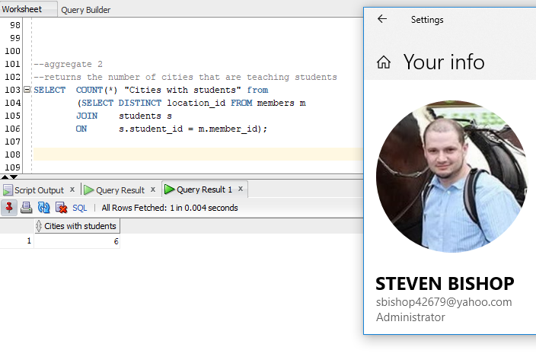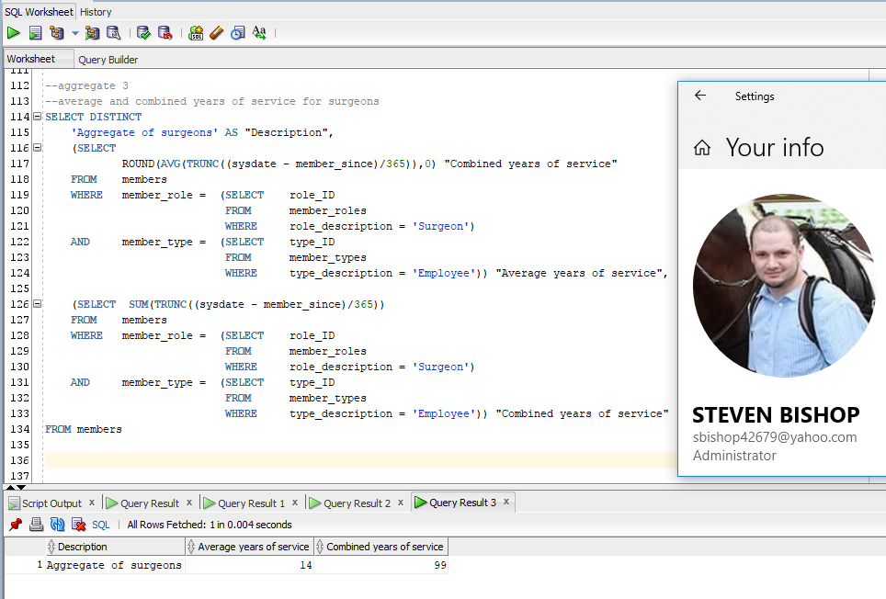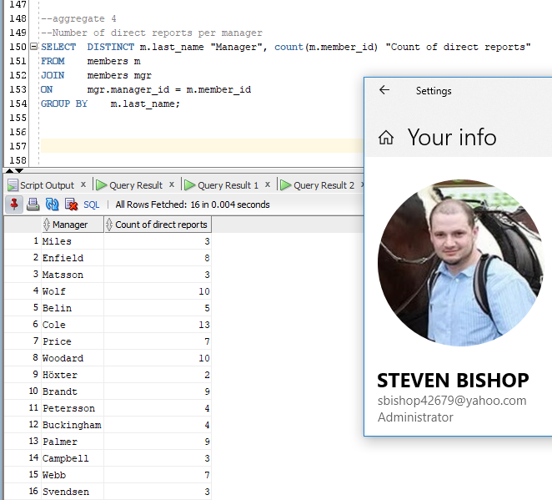

## REPORTS

